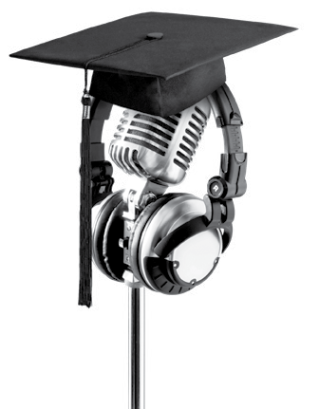
CBA Scholarships 2022

Application Form
We are excited to hear that you are planning to embark on a career in media. This application is open to media, communication, journalism, film, radio and audio engineering students who have been accepted to study at an NZQA accredited institution. All applicants must be New Zealand citizens or permanent residents.
We look forward to receiving your application!

If you have any issues or questions, please contact our Scholarship Secretary, Erin Carpenter, at scholarships@cba.org.nz
Please note -
To complete this application you need to include:

- this form (including privacy form on the final page).

- three referee letters.

It is your responsibility to ensure that all forms, including the three referee letters, are received by CBA no later than 5pm, Wednesday, 11th May 2022. Please make sure you follow up with your referees to make sure they have sent in their submission directly to CBA before the deadline.
We would appreciate your help by writing clearly or typing. Use additional sheets of paper if you wish but please ensure that they are attached to these forms when you send in your application.

Personal information
Mr Mrs Ms Miss

First name Last name

Permanent address

Postcode

Telephone ( ) Cellphone ( )

Email

Term address (if known and different from permanent address)

Postcode

Name of church/Christian community which you are currently attending/part of

Address

Postcode

Referees
You are required to supply three references in support of your application. It is your responsibility to give each of them the two-page ‘referee’s document’ (p2. provides background information to the referee). However, we still require their names below, for cross referencing.
Your three referees are:

Spiritual

Education

Other/character

Course and study information
Remember, we base our decision solely on what you tell us in this application form and the referees’
submissions.

Name of the NZQA tertiary institution where you are currently enrolled to study

Name of the course you will study/are studying

What is your academic record to date, including qualifications gained at secondary school? Please provide the relevant year, the educational institution attended and the qualification(s) attained.

Why have you chosen this field of study?

Where do you hope to be working in 5/10 years?

One of the scholarships is ‘The CBA Hillman Award’ - awarded to a candidate who has an interest in working in radio and/or audio engineering. If you are wanting to pursue a career in one of these two areas, then tell us more about what you hope to achieve.

Outside of work and study, what are you passionate about? What do you enjoy doing?

Have you taken leadership roles, in any capacity? If so, please give details.

What role does prayer play in your life, and why?

What role has your faith played in your decision to pursue a career in media?

How did you find out about the CBA scholarships?

Please add any further information that you think may be helpful in assisting the selection team:

CBA Scholarships 2022

Privacy Form
Personal information contained in your application will be made available to members of the CBA Scholarship Selection Team, who may also use references from third parties designated by yourself, in assessing your application.
We take your privacy seriously. Should you have reason to believe that information held about you is incorrect, you have the right of access to, and correction of, that information.
Personal references from the persons you have named are obtained on the strict understanding that they are confidential, and you may not have access to those references under any circumstances.
Applicants shall agree to the Selection Team obtaining academic or other information necessary to
assess their application.

Applicants shall agree to co-operate with any publicity relating to the Scholarship. Such publicity may include material provided with your application, photographs and interviews with Scholarship awardees.

I,

agree to the above conditions in respect of my Scholarship application.

Signed Date

Please note, this application (including signed privacy form) should be emailed to info@cba.org.nz no later than 5pm, Wednesday, 11th May 2022.
Alternatively, it can be posted to the following address (allow 4 days for mail to be processed by NZ Post):
FreePost 69602 CBA Scholarships PO Box 100
Shortland Street Auckland 1140
Please also ensure that your referees are aware of this deadline. Thank you.

